OER Research Hub

Evaluation Framework

Contents
Evaluation Framework 1
1.0 Document Control 3
1.1 Version History 3
1.2 Changes Forecast 3
1.3 Distribution 3
1.4 Related Documents and Forms 4
2. Purpose of document 4
3. Introduction 4
4. Evaluation 4
4.1 Defining evaluation 5
4.2 Evaluation types, approaches, principles and planning tools 5
4.3 A collaborative approach to evaluation 10
4.4 The relationship between monitoring and evaluation 10
4.5 Evaluation drivers 10
5. About the OERRH project 11
5.1 Project objectives 12
5.2 Project approach: collaboration and openness 12
5.3 Project stakeholders 13
5.4 Project outputs and outcomes and logic model 15
6. A two-phase framework for evaluation of OERRH 18
6.1 Phase 1: formative evaluation of the research methods, analysis and dissemination 18
6.1.1 What aspect(s) of the project should be evaluated? 19
6.1.2 Who is the evaluation for? 19
6.1.3 What is it they want to find out? 19
6.1.4 What evaluation methods will be used? 19
6.1.5 What changes will be made when the results are gathered? 20
6.1.6 What are the evaluation criteria and what is their source? 20
6.1.7 When will the evaluation take place? 20
6.1.8 Who will be involved in the evaluation? 20
6.1.9 What constraints will be placed upon the evaluation? 21
6.1.10 How and when will the evaluation results be disseminated? 21
6.2 Phase 2: Summative evaluation of the project outputs and short- to medium-term outcomes 24
6.2.1 What aspect(s) of the project should be evaluated? 24
6.2.2 Who is the evaluation for? 24
6.2.3 What is it they want to find out? 25
6.2.4 What evaluation methods will be used? 25
6.2.5 What changes will be made when the results are gathered? 25
6.2.6 What are the evaluation criteria and what is their source? 25
6.2.7 When will the evaluation take place? 26
6.2.8 Who will be involved in the evaluation? 26
6.2.9 What constraints will be placed upon the evaluation? 26
6.2.10 How and when will the evaluation results be disseminated? 26
7. Conclusion 29
8. References 29

Author: Dr Leigh-Anne Perryman, Research Associate
IET
leigh.a.perryman@open.ac.uk
Ext: 58618

An evaluation framework provides guidelines that allow project processes, outputs and outcomes to be evaluated in ways appropriate to the individual concerns of various work packages, while at the same time collecting data which can be pulled together across the project.

1.0 Document Control
Document Identifier: | OER Research Hub Evaluation Framework | Date due: | 31/03/13
Class Deliverable: | OER Research Hub WP5 | Submission date:
Project start date: | 1 September 2012 | State: | Draft
Project duration: | 24 months

1.1 Version History
Date | Version | Stage | Summary of changes
29/04/2013 | v0.1 | Initial draft | Initial draft by Leigh-Anne Perryman
10/05/2013 | v0.2 | Revised draft | Comments and edits, revised by Leigh-Anne Perryman
14/06/2013 | v0.3 | Revised draft | Revised draft by Leigh-Anne Perryman
05/07/2013 | v1.0 | Final version | Approved by Patrick McAndrew

1.2 Changes Forecast
The Evaluation Framework will be revised following the Phase 1 evaluation. The next planned update will be with Stage 4 deliverables on 30 September 2013.

1.3 Distribution
Name | Organisation/Role
Author(s):
Leigh-Anne Perryman | Research Associate
Reviewers:
Martin Weller | Co-Investigator
Rob Farrow | Research Associate
Approvers:
Project Board
Patrick McAndrew | Principal Investigator

1.4 Related Documents and Forms
Item | Description of Document
1 | Project Proposal
2 | Work Package Descriptions (all)
3 | Ethics Manual
4 | Dissemination Framework
5 | Quality Plan
6 | Research Framework
7 | Individual Collaboration Frameworks (proformas)
8 | Reflection Diary

2. Purpose of document
The object of this document is to provide an evaluation framework for the OER Research Hub (OERRH) project. It begins with an overview of the reasons for evaluation, focusing on evaluation definitions, approaches and drivers. The OERRH project is then introduced and the document continues with a detailed outline of the proposed two phase evaluation framework, explaining how this fits into the context of evaluating a multi-collaboration open project.

3. Introduction
The OER Research Hub Evaluation Framework is intended to provide guidelines that allow the project processes, outputs and outcomes to be evaluated in ways appropriate to the individual concerns of the various work packages, while at the same time collecting data which can be pulled together across the project. The Evaluation Framework is informed by the OERRH project logic model and is intended to be appropriate to the project focus on openness and collaboration.

4. Evaluation
Evaluation is typically conducted for two main reasons: (i) to inform decisions related to the on-going operation of a project and/or policies and strategies related to the design of future projects; (ii) To demonstrate accountability to funders, showing whether the project objectives have been achieved and whether their money has been well-spent.
More specifically, the objectives of project evaluation often include:
- Developing a body of knowledge about what works, what does not work, and why;
- Improving the quality of a project;
- Identifying successful processes and strategies for replication and expansion;
- Modifying unsuccessful processes and strategies;
- Measuring the impact of a project and the benefits for stakeholders;
- Giving stakeholders a say in the project output and quality;
- Demonstrating to funders the effectiveness of a project.
The OERRH evaluation framework is intended to achieve all of these objectives.

4.1 Defining evaluation
The Hewlett Foundation Evaluation Principles and Practices states that ‘evaluation is an independent, systematic investigation into how, why, and to what extent objectives or goals are achieved’ (Twersky & Lindblom, 2012, p. 3) whilst the Kellogg Foundation (2012, p.2) Framework for Evaluation states that evaluation should provide ‘ongoing, systematic information that strengthens projects during their life cycle, and, whenever possible, outcome data to assess the extent of change’, adding that ‘the evaluation effort should leave an organization stronger and more able to use such an evaluation when outside support ends’. The JISC Six Steps to Effective Evaluation handbook (Glenaffric Ltd, 2007, p.2) states that evaluation ‘can and should be viewed as an essential and important element to a well-managed project that recognises the value of timeous insights into the project’s progress and successful outcomes’ and ‘can be defined as any organised activity that helps draw out the value and prove the worth of development projects’.

4.2 Evaluation types, approaches, principles and planning tools
A plethora of evaluation approaches exist within the field of education and educational technology alone. Navigating these approaches has been an important part of devising an Evaluation Framework for OERRH. Choosing an evaluation approach involved a number of considerations, including:
- The extent to which the approach was complementary with the open ways of working embedded in the OERRH project;
- The extent to which the approach aligned with the collaborative OERRH working practices;
- The appropriateness of the approach in terms of the areas covered and the intended outcomes of evaluation.
An early consideration involved deciding on the type of evaluations that should be conducted. Trochim (2006) provides a typology of formative and summative evaluation types:
Formative evaluation includes several evaluation types:
- needs assessment determines who needs the program, how great the need is, and what might work to meet the need
- evaluability assessment determines whether an evaluation is feasible and how stakeholders can help shape its usefulness
- structured conceptualization helps stakeholders define the program or technology, the target population, and the possible outcomes
- implementation evaluation monitors the fidelity of the program or technology delivery
- process evaluation investigates the process of delivering the program or technology, including alternative delivery procedures
Summative evaluation can also be subdivided:
- outcome evaluations investigate whether the program or technology caused demonstrable effects on specifically defined target outcomes
- impact evaluation is broader and assesses the overall or net effects -- intended or unintended -- of the program or technology as a whole
- cost-effectiveness and cost-benefit analysis address questions of efficiency by standardizing outcomes in terms of their dollar costs and values
- secondary analysis re-examines existing data to address new questions or use methods not previously employed
- meta-analysis integrates the outcome estimates from multiple studies to arrive at an overall or summary judgement on an evaluation question
The OERRH Evaluation Framework features implementation evaluation and process evaluation in its formative evaluation phase and outcome evaluation, impact evaluation and secondary analysis in its summative evaluation phase.
In addition, the OERRH Evaluation Framework is informed by principles and planning tools from three main sources - the Hewlett Foundation Evaluation Principles and Practices (Twersky & Lindblom, 2012), the Kellogg Foundation Framework for Evaluation (2012) and the JISC Six Steps to Effective Evaluation handbook (Glenaffric Ltd, 2007). The Hewlett Foundation identifies seven principles that guide its evaluation practice:
- We lead with purpose
- Evaluation is a learning process
- Evaluation is an explicit and key part of strategy development
- We strategically choose what to evaluate
- We choose methods that maximize rigor without compromising relevance
- We share our findings with appropriate audiences
- We use the data!
(Twersky & Lindblom, 2012)

Of these principles, numbers 2, 4, 5, 6 and 7 are particularly pertinent to the development of the OERRH Evaluation Framework, especially in terms of the ways in which they embrace open practice and the mindful choice of focus and methods.
The Kellogg Foundation’s Framework for Evaluation has been similarly influential, especially the following principles (Kellogg Foundation, 2012, pp. 2-3):
- ‘Strengthen projects’ - the use of evaluation information to ‘strengthen projects during their life cycle’ and, where possible, ‘the use of outcome data to assess the extent of change’;
- ‘Use multiple approaches’ and a range of techniques to address important project questions;
- ‘Create a participatory process’ - value multiple perspectives and involve a representation of people who care about the project;
- ‘Allow for flexibility’ - avoid rigid or prescriptive evaluation plans in favour of ‘an emergent approach, adapting and adjusting to the needs of an evolving and complex project’.
- ‘Build capacity’ - ‘encourage self-reflection and dialogue on the part of every person involved with evaluation in order to reach increasingly sophisticated understandings of the projects being evaluated’.
In addition to the principles identified above, the OERRH Evaluation Framework draws on two evaluation planning tools - the project evaluation activities specified by the Kellogg Foundation (Figure 1) and JISC’s six step evaluation approach (Figure 2).

Pre-project: | - Assess needs and assets of target population/community
 | - Specify goals and objectives of planned services/activities
 | - Describe how planned services/activities will lead to goals
 | - Identify what community resources will be needed and how they can be obtained
 | - Determine the match between project plans and community priorities
 | - Obtain input from stakeholders
 | - Develop an overall evaluation strategy
Start-up: | - Determine underlying program assumptions
 | - Develop a system for obtaining and presenting information to stakeholders
 | - Assess feasibility of procedures given actual staff and funds
 | - Assess the data that can be gathered from routine project activities
 | - Develop a data-collection system, if doing so will address desired question
 | - Collect baseline data on key outcomes and implementation areas
Implementation and Project Modification: | - Assess organizational processes or environmental factors which are inhibiting or promoting project success
 | - Describe project and assess reasons for changes from original implementation plan
 | - Analyze feedback from staff and participants about success/failures and use this information to modify the project
 | - Provide information on short-term outcomes for stakeholders/decision-makers
 | - Use short-term outcome data to improve the project
 | - Describe how you expect short-term outcomes to affect long-term outcomes
 | - Continue to collect data on short- and long-term outcomes
 | - Assess assumptions about how and why program works; modify as needed
Maintenance and Sustainability: | - Share findings with community and with other programs
 | - Inform alternative funding sources about accomplishments
 | - Continue to use evaluation to improve the project and to monitor outcomes
 | - Continue to share information with multiple stakeholders
 | - Assess long-term impact and implementation lessons, and describe how and why program works.
Replication and Policy: | - Assess project fit with other communities.
 | - Determine critical elements of the project which are necessary for success.
 | - Highlight specific contextual factors which inhibited or facilitated project success.
 | - As appropriate, develop strategies for sharing information with policymakers to make relevant policy changes.
Figure 1: The Kellogg Foundation ‘possible project-level evaluation activities’ (Kellogg Foundation, 2012, p. 16)

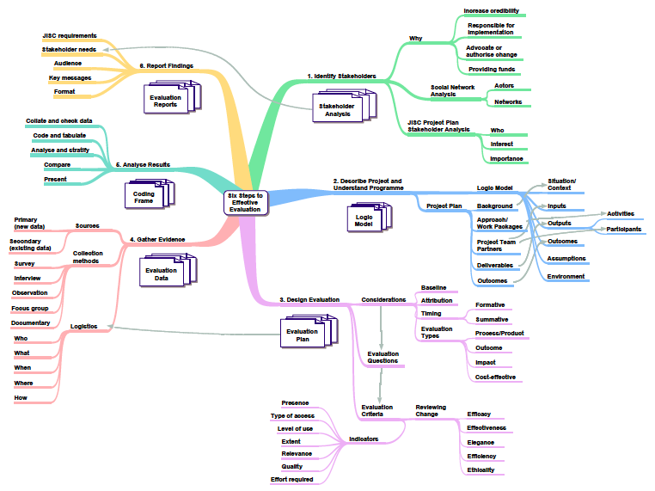
Figure 2: The JISC six steps to effective evaluation (Glenaffric Ltd, 2007, p. 3)

Finally, the OERRH Evaluation Framework is also informed by the work on evaluation conducted by academics working on projects based at the Open University’s Institute of Educational Technology, (e.g. Clough, 2009; Scanlon et al, 2007), though as such evaluation is largely focused on assessing the effectiveness of learning technology systems the influence on the OERRH Evaluation Framework has been in terms of broad principles rather than specific practices.

4.3 A collaborative approach to evaluation
The Kellogg Foundation (2012, p. 2) Framework for Evaluation is unambiguous in its assertion that evaluation should be a collaborative process, stating that ‘just as people participate in project activities, people must participate in project evaluation. The best evaluations value multiple perspectives and involve a representation of people who care about the project’. The OERRH project has collaboration at its core, both in the relationship between the project team and external OER projects and in the ways in which the project team itself works. (This is explained in more detail in Section 4.2.) For this reason the OERRH Evaluation Framework is collaborative throughout, involving all project stakeholders in the evaluation process wherever possible.

4.4 The relationship between monitoring and evaluation
Monitoring continuously tracks project performance against what was initially planned, using regular reporting systems and record-keeping to provide on-going information about whether progress is being made towards achieving the project outputs and outcomes. The information generated from monitoring activities allows for learning from experience and informs future decision-making. OERRH has a strong and extensive monitoring system, initiated by the project management team and featuring the input of all project team members. Examples of project monitoring include the requirement to keep the collaboration research methods pro-forma updated, the regular project health-checks and the monthly work package progress reports. Evaluation is a periodic, more in-depth analysis of project performance than monitoring and while monitoring and evaluation are intimately related, neither is a substitute for the other. Both monitoring and evaluation may be conducted in similar ways, but each produces different kinds of information. Twersky and Lindblom (2012, p. 3) point out that ‘evaluation will often draw on...monitoring data but will typically include other methods and data sources to answer more strategic questions’.

4.5 Evaluation drivers
The evaluation guidelines, principles, frameworks and planning tools informing the OERRH Evaluation Framework cover common ground in identifying core questions that evaluators need to ask when planning an evaluation, and which drive all evaluations:
- What aspect(s) of the project should be evaluated?
- Who is the evaluation for?
- What is it they want to find out?
- What evaluation methods will be used?
- What changes will be made when the results are gathered?
- What are the evaluation criteria and what is their source?
- When will the evaluation take place?
- Who will be involved in the evaluation?
- What constraints will be placed upon the evaluation?
- How and when will the evaluation results be disseminated?
Focusing on these questions will help to ensure that any evaluation is useful, timely and relevant. The questions are addressed in detail in the context of the proposed two-phase OERRH evaluation framework discussed in Section 5 and provide a structure for outlining the detail of this evaluation framework.

5. About the OERRH project
The OER Research Hub is a Hewlett foundation funded project being led by the Institute of Educational Technology at the Open University (UK) (http://www.open.ac.uk/iet/main/). The project provides a focus for research, designed to give answers to the overall question ‘What is the impact of Open Educational Resources (OER) on learning and teaching practices?’ and identify the particular influence of openness. To achieve these aims the OERRH team are working in collaboration with projects across four education sectors (K12, college, higher education and informal) extending a network of research with shared methods and shared results.
The project combines:
- A targeted collaboration program with existing OER projects;
- An international fellowship program;
- Networking to make connections; and
- A hub for research data and OER excellence in practice.

These activities are illustrated in Figure 3.
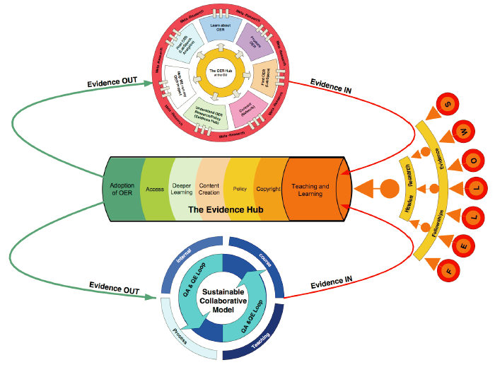
Figure 3: The activities of the OERRH project

5.1 Project objectives
It is aimed that by the end of the OERRH project’s research phase evidence will have been gathered showing what works and when in terms of the use of OER in diverse teaching and learning contexts, and that the research team will also have also established methods and instruments for broader engagement in researching the impact of openness on learning. The evidence generated via research collaborations will contribute to this overall aim, whilst providing a legacy for policy change and practice.

5.2 Project approach: collaboration and openness
The OERRH project operates on a collaborative rather than partnership model. It features a dual research approach, combining both remote monitoring of publicly available data and the development of research instruments which are applied through a combination of direct and facilitated research.
The core group of collaborating projects, as mentioned in the OERRH bid, is as follows:
- The Flipped Learning Network
- Gulf of Maine Research Institute
- The Open Course Library (OCL) in Washington State
- The Community College Consortium for OER (CCCOER)
- Connexions/OpenStax College
- TESS-India
- School of Open/P2PU
- Bridge to Success
- OpenLearn
The OERRH approach to collaboration combines research with practical assistance and it is hoped that this will bring benefits to all involved and will also provide an enhanced flow of research data. The OERRH collaborations cover different sectors and issues, these include: the opening up of classroom based teaching to open content; the large-scale decision points implied by open textbooks for community colleges; the extension of technology beyond textbook through eBook and simulation; the challenge of teacher training in India; and the ways that OER can support less formal approaches to learning. By basing good practice on practical experience and research it is intended that the project will help tackle practical problems whilst building the evidence bank needed by all.
Meeting the challenges of openness requires research strategies which take account of the different aspects of OER impact. In the OER world, the way forward is associated with greater transparency and sharing of educational materials and research. Similarly, a more useful evidence base should emerge through taking advantage of working openly and in collaboration as it allows for the pooling of limited resources and greater scale and efficiency through co-ordinated action.

5.3 Project stakeholders
The project stakeholders will include (but are not limited to) The Hewlett Foundation; The Open University; IET; collaborating projects; the OER Research Hub project team; the OERRH Fellows, OER users and potential users (institutions, educators and formal/informal learners) and the OER and open education movements. Table 1 provides a fuller analysis of the OERRH stakeholders.

Stakeholder | Interest/Stake | Importance
Project management team | Ensuring the provision of the resources that will allow the project to meet its objectives. | High
Project researchers | Professional reputation; ensuring that work is carried out to accepted methodological, epistemological and ethical standards. | High
Project principal investigator & co-investigator | Professional reputation; ensuring that work is carried out to accepted methodological, epistemological and ethical standards. | High
The Open University | Opportunities to develop a better understanding of the impact of OER on their base of teachers and students; contribution to research profile aligns with strategic priorities. | Medium
Institute of Educational Technology | As part of the IET research portfolio, OERRH contributes to maintaining a reputation for leading research into openness in education and in educational technology more generally. | Medium
Collaborating projects | A chance to outsource research needs and better contextualise projects’ own work. Good practice can be identified and disseminated. The national/international profile of OER projects can be raised. | Varied according to institutional or operational objectives
The Hewlett Foundation | Getting value for funding input. Ensuring that project stated objectives, outputs and outcomes have been achieved. Furthering knowledge of what works in terms of OER use and development. | High
The OERRH Fellows | Opportunities for professional development; networking & collaboration; novel research opportunities | Medium
OER users and potential users (institutions, educators and informal/formal learners) | Improved understanding of OER impact should facilitate the development of better quality OER and pedagogies which make use of them. | Varied
The OER and open education movements | Raising the profile of the open education movement and of OER generally. Aggregated research should be of benefit to the movement as a whole. | Medium

Table 1: Analysis of the OERRH project stakeholders

5.4 Project outputs and outcomes and logic model
The OERRH project comprises six work packages:
- WP1: Management
- WP2: Collaborative Research
- WP3: Collaborations and Fellowships
- WP4: OER Evidence Hub
- WP5: Evaluation
- WP6: Dissemination
The main outputs of the project include:
- A research framework detailing the OERRH overall research strategy and approach;
- Research data (presented in raw open data format and also packaged in the form of collaboration-linked and other reports, conference papers, journal articles and other dissemination formats);
- The Evidence Hub: This online research database and communication platform functions as a research ‘base’ with practical outcomes i.e. containing content/evidence from our own and other global projects.
- Further development of the OER Hub at the OU: The OER Hub provides expertise or routes to expertise for technical, management and processes associated with the successful conversion of course material to OER for example Learning Design analysis for OER, evaluation, accessibility and production best practice. It is intended to apply this support into the research collaborations and extend it through a range of OER courses and web presence: to provide best practice and advice on running course pilots, surveying instructors, students etc. and to continue to conduct our own research in this area. It is also intended to extend the existing provision of face-to-face courses and web-based information for use by educators to an international audience.
- A “How to conduct OER research” pack produced first for use in the collaborations and then as a public, openly licensed document and section of the website. The open-license research instruments featured in the pack will include schedules for semi-structured interviews, guidance notes for conducting focus groups (including hypothesis-related topic guides), a bank of survey questions and guidance for the design of surveys incorporating these questions, an analysis strategy for analysis and interpretation of the quantitative and qualitative data collected through the survey questions, focus groups and interviews, and identification of quantifiable factors either gathered as secondary data or direct analytics;
- An Ethics Manual;
- The project website.
The key outcomes of the OERRH project will be:
- Research: establishing a greater understanding of the priority research questions on the impact of OER on teaching and learning;
- Collaborations: through the research and collaboration program, developing a shared framework that helps both address these questions and enable their research, allowing collaborating projects to benefit from development and advice from the OERRH project team and linked-fellows;
- Fellowships: through the fellowship program, enhancing collaboration and communication across OER projects and providing the space and time for understanding of OER-related research issues;
- Establishing and developing an on-going, sustainable OER Hub at the OU for informing decision making in this area.

The project logic model is shown in Figure 4.

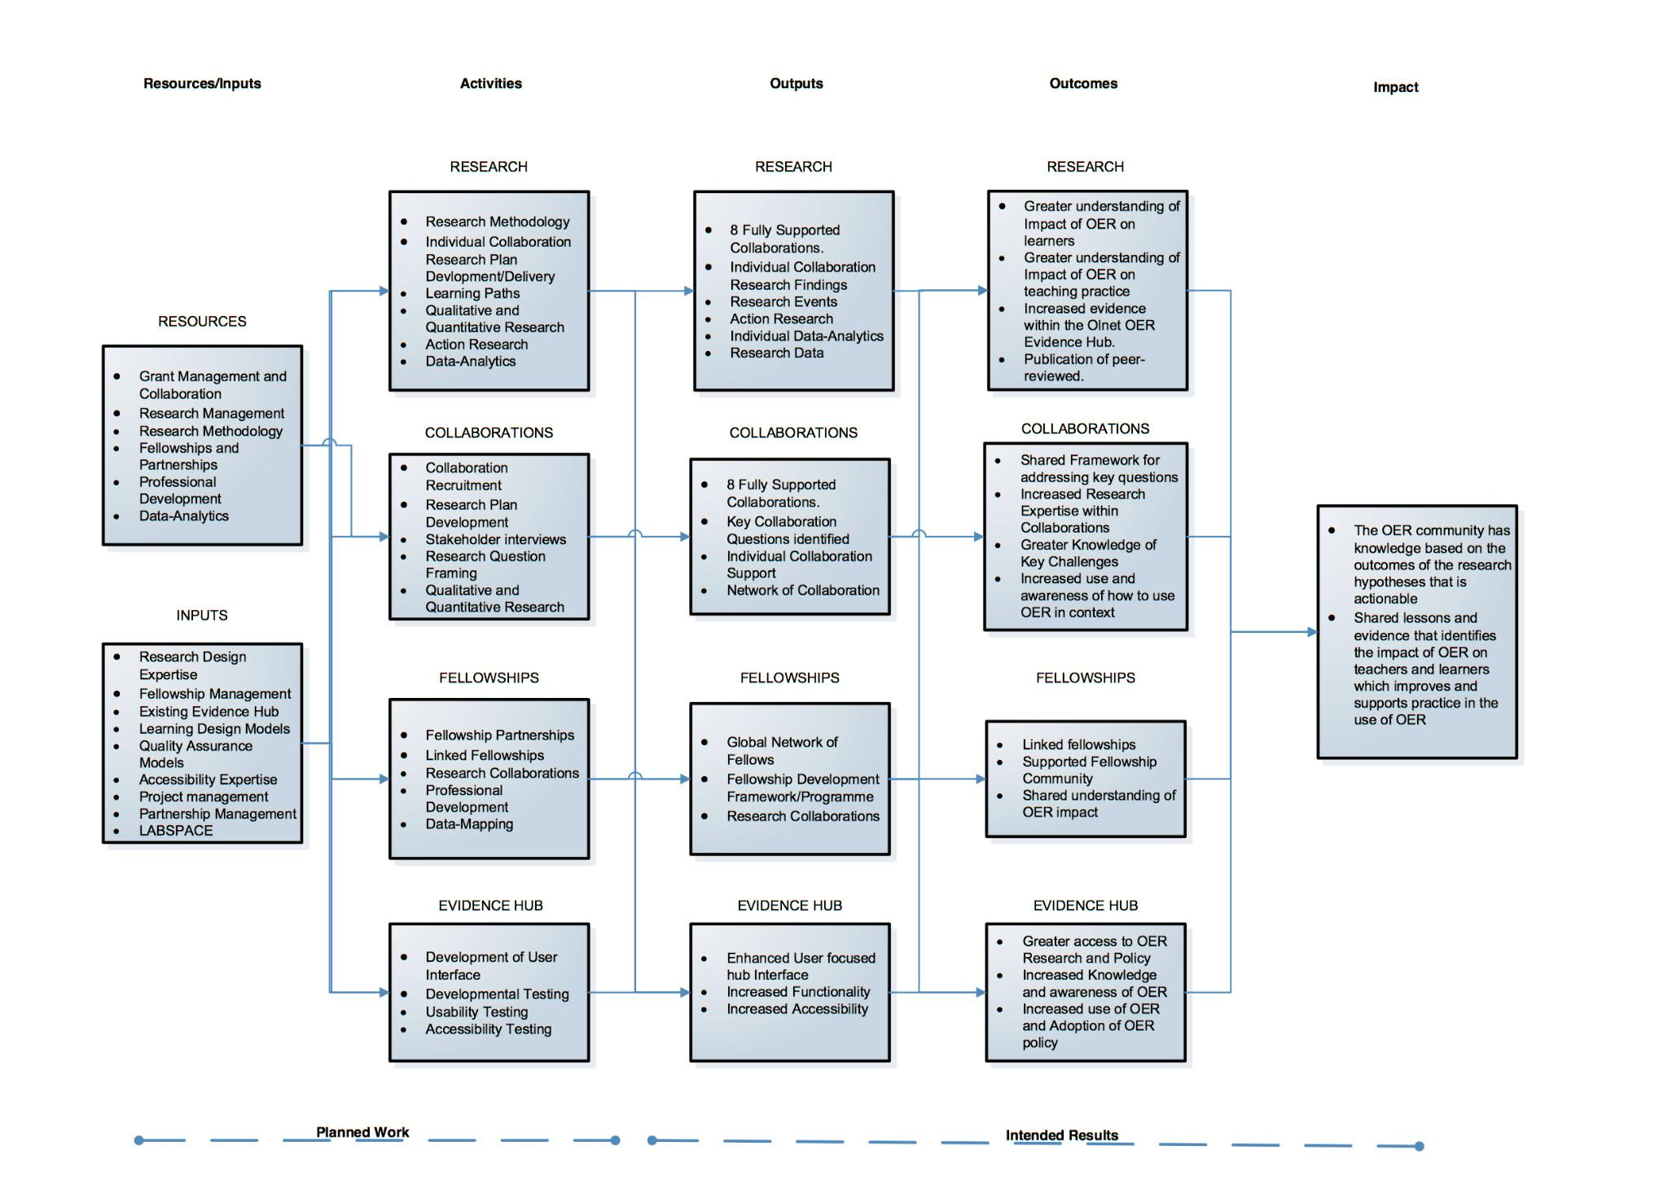
Figure 4: The OERRH logic model

6. A two-phase framework for evaluation of OERRH
Hewlett Foundation evaluation principle 4 (Twersky & Lindblom, 2012, p. 5) states that ‘we cannot evaluate everything, so we choose strategically’, adding that decisions about what to evaluate are guided by criteria including the opportunity for learning. In addition, they warn that projects should ‘NOT sacrifice relevance by having evaluation findings be delivered too late to matter’ (Twersky & Lindblom, 2012, p. 16). Accordingly, the OERRH evaluation framework is structured on a two-phase basis intended to prioritise the opportunities for learning from the evaluation process and for effecting change informed by these learning opportunities.
Phase 1 comprises a process of formative evaluation focused on the project research and intended to inform decisions about data collection and analysis methods, the interpretation of the research data, and the strategy for disseminating the research findings (including the Evidence Hub). The formative stages of the evaluation process will allow for intervention in any aspect of the project that is in risk of falling short of agreed goals and, in turn, will help ensure that the interests of the various project stakeholders are served. The formative evaluation stages will also serve to strengthen and fine-tune key project processes through evidence informed collaboration between an Evaluation Fellow and the OERRH research team. As such, it is closely aligned with the Hewlett Foundation’s evaluation principle 7 - ‘We use the data!’.
Phase 2 - the summative stage of the OERRH evaluation process will allow the project outputs and outcomes to be assessed against the originally intended objectives, providing lessons for future projects in addition to evidence about whether the project has achieved its stated goals and has benefitted its stakeholders. The formative and summative evaluation of the OERRH project is intended to allow on-going monitoring of the project health, leading to evaluation-informed project development activities and the implementation of quality assurance at all stages of the project.
The results of both phases of the evaluation process will be openly shared with all interested stakeholders, in line with the Hewlett Foundation’s evaluation principle 6 - ‘We share our intentions to evaluate, and our findings, with appropriate audiences’.

6.1 Phase 1: formative evaluation of the research methods, analysis and dissemination
Phase 1 of the OERRH evaluation is a formative process, to take place at key points during the life of the project. The Phase 1 evaluation is intended to:
(a) locate the OERRH research findings in the broader context of existing OER research;
(b) evaluate the data collection and analysis methods;
(c) evaluate the ways in which ethical considerations are being managed;
(d) contribute to interpreting the research findings;
(e) evaluate the dissemination of the research findings.

6.1.1 What aspect(s) of the project should be evaluated?
Phase 1 of the OERRH evaluation focuses on aspects of Work Package 2 - ‘Collaborative Research’ and on Work Package 6 - ‘Dissemination’.

6.1.2 Who is the evaluation for?
The Phase 1 evaluation is primarily intended to benefit the OERRH research team, helping them to strengthen and fine-tune their research strategy, as appropriate, throughout the life of the project. In addition, Phase 1 has relevance to the project stakeholder group as a whole in ensuring that the research is conducted to the highest possible standard and that the dissemination of research conclusions is as effective as possible.

6.1.3 What is it they want to find out?
The OERRH research team wish to find out about ways in which their data collection and analysis strategies could be improved/fine-tuned in order to better explore the OERRH research hypotheses. They also wish to find out whether the research conclusions derived from the collected and analysed data are valid and reliable and whether alternative conclusions and interpretations might be reached. The project team as a whole, in addition to the broader group of stakeholders identified in Section 5.3, wish to find out whether ethical considerations are being well-managed and whether the project dissemination strategy and activities could be improved in order to better achieve the project impact goals.
The Hewlett Foundation (Twersky & Lindblom, 2012, p. 14) assert the value of evaluation being ‘guided by clear, crisp questions’. They explain that:
Crafting a short list of precise questions increases the odds of receiving helpful answers—and a useful evaluation. Well-designed questions about an initiative or program can clarify not only the expected results but also surface assumptions about its design, causality, time frame for results, and data collection possibilities. These surfaced assumptions and questions can then help sharpen a theory of change and ensure effective planning for knowledge generation and learning.
The evaluation questions listed in Table 2 below give more detail about the areas that are to be investigated in Phase 1.

6.1.4 What evaluation methods will be used?
The Hewlett Foundation (Twersky & Lindblom, 2012, p. 17) point out that ‘most strong evaluations use multiple methods to collect and analyse data’ and that ‘this process of triangulation allows one method to complement the weaknesses of another’, adding that ‘as part of early planning, it is ideal to select methods that match evaluation questions’. The Phase 1 suggested evaluation methods are detailed in Table 2. They are designed to offer triangulation that should, in turn, maximise rigor and minimise bias, allowing for a comparison across investigators and data sources.

6.1.5 What changes will be made when the results are gathered?
Phase 1, being a formative process of evaluation, will allow the OERRH team to respond swiftly to any recommendations made by the Evaluation Consultant, with the aim of strengthening the data collection, analysis and interpretation process, ensuring that ethical guidelines are being followed and contributing to the development of an effective dissemination strategy. Twersky and Lindblom (2012, p. 20) suggest that ‘from the very beginning of the evaluation process, it helps tremendously to plan how the results will be used; along the way, it is wise to remind yourself of those intended uses’. They recommend that ‘often a short exercise of predicting the findings can helpfully surface assumptions about them and generate discussion about what might be done differently if these assumptions are not borne out’. This process of scenario-based reflection by all project team members is inherent to the Phase 1 evaluation process.

6.1.6 What are the evaluation criteria and what is their source?
The criteria for the evaluation are outlined very broadly in Table 2 and it is expected that the Evaluation Consultant will specify more detailed evaluation criteria for the research outputs based on accepted techniques for evaluating mixed methods educational and educational technology research in addition to an understanding of the project’s stated outputs and outcomes as identified in the Project Plan.

6.1.7 When will the evaluation take place?
The evaluation timescale is specified in Table 2.

6.1.8 Who will be involved in the evaluation?
The Phase 1 evaluation will be structured around the evaluation framework detailed in this document and will involve all members of the OER Research Hub team, in addition to a Phase 1 Evaluation Consultant (EC) (to be appointed). It is recommended that the Evaluation Consultant should be someone with a good reputation within the open education/OER movement and a strong knowledge of current research developments in this field. It is also recommended that this person should have strong qualitative and quantitative research skills (covering both data collection and analysis). The Evaluation Consultant will work in close collaboration with the OERRH team to discuss the quality of their research outputs and the effectiveness of the research dissemination processes. More detail about the people involved in the Phase 1 evaluation is provided in Table 2.

6.1.9 What constraints will be placed upon the evaluation?
The main constraints on the Phase 1 evaluation will be the challenges of drawing together research data and findings from disparate sectors and contexts, where collaborations are working to differing timescales. (For example, while it will be possible to evaluate the Flipped Learning Network research methods quite early in the life of the project, the delayed start of the TESS-India (T-I) project will prevent evaluation of the T-I research methods until at least February 2014.)

6.1.10 How and when will the evaluation results be disseminated?
It is intended that the evaluation results will be promptly disseminated amongst the research team throughout the life of the project. The dissemination methods have yet to be finalised but it is likely that they will include fortnightly emailed reports to the entire OERRH team by the WP5 lead, covering evaluation-related issues, in addition to bi-monthly reports to the Work Package Leader’s meeting by the WP5 lead. More detail is provided in Table 2.

Evaluation questions | Indicative evaluation methods and interaction with the project team | Timescale | Indicative recommendations informed by the evaluation process
Are the existing research methods sufficient for exploring the stated hypotheses? | - On-going researcher self-reflection, individually (e.g. at key decision-making points and pre-, during-, and post-visits) and collectively (e.g. at Reflection Away Day). A copy of any written reflection to be pasted into the Google Drive Reflection Diary to allow evaluation.  - Feedback from collaborations (especially post-research visits).  - EC assesses research outputs (e.g. the results of hypothesis sprints) for clarity, validity, reliability and robustness, as appropriate (in addition to other criteria, yet to be specified).  - EC gives feedback to the project team. | Team reflection: to start immediately. Other methods: To begin once the EC is recruited. | Additional research methods/approaches.
Are the analysis techniques appropriate to the data collected? | - Researcher/project team self-reflection, as above.  - EC feedback on research outputs to include consideration of the analysis techniques.  - EC discusses analysis techniques with the researchers involved and with the project team as a whole. | Team reflection: to start immediately. Other methods: At start of analysis process, once an analysis strategy has been produced, and at key points thereafter. | Additional analysis approaches and techniques.
Are the research conclusions reliable (free of measurement error) and valid (in terms of both internal and external validity)? | - Researcher/project team self-reflection, as discussed above.  - EC assess research outputs (e.g. the results of hypothesis sprints, blog posts, journal articles) for clarity, validity, reliability and robustness, as appropriate (in addition to other criteria, yet to be specified).  - EC gives feedback to the project team. | Reflection process to start immediately. Other methods: As and when research is reported in any format (including at key points during the analysis process). | Ways of improving the reliability of research conclusions.  Identify invalid interpretations of the data and offer alternative interpretations/a different perspective.
Could the research hypotheses be explored in a different way? | - Researcher/project team self-reflection.  - WP5 Lead assessment of the Reflection Diary. | Reflection process to start immediately. Other methods: Periodically throughout the research life of the project. | Additional research methods/approaches/collaborations.
Are ethical considerations being managed appropriately? | - Reflection by the researchers and broader project team, recorded in the Reflection Diary and as incidents elsewhere.  - WP5 Lead assessment of Reflection Diary contents. | Reflection process to start immediately. Other methods: Periodically throughout the research life of the project, perhaps prompted by individual researchers. | Alternative/additional ways of managing ethical considerations.
Are the research findings being disseminated effectively, both through the Evidence Hub and through other dissemination methods (including conference presentations, journal articles, Twitter, the OERRH website)? | - Reflection by the researcher and broader project team.  - EC evaluates the OERRH dissemination strategy and dissemination activities and discusses these activities with the project team. | Reflection process to start immediately. Other methods: Periodically through the life of the project. | Alternative/additional methods of dissemination.
Are the research findings suitably contextualised within the broader context of OER/open education research? | - EC gives feedback on the ways in which research outputs (blog posts, sprint reports, journal articles) could be better contextualised in the list of recent OER/open education research findings. | Final six months of the project. | Links with other relevant research

Table 2: Details of the Phase 1 evaluation process

6.2 Phase 2: Summative evaluation of the project outputs and short- to medium-term outcomes
Phase 2 of the OERRH evaluation is a summative process, to take place towards the end of the project. The Phase 2 evaluation is intended to:
(a) evaluate a selection of the project outputs - the deliverables identified in the Project Plan - in terms of their quality, fitness for purpose and timely delivery;
(b) evaluate the project short-term and medium term outcomes, specifically the project’s impact on the various stakeholders, its contribution to knowledge in the field of OER and open education research, and its sustainability beyond funding.

6.2.1 What aspect(s) of the project should be evaluated?
Phase 2 of the OERRH evaluation focuses on aspects of all 6 Work Packages, with particular emphasis on project outputs and outcomes. Further detail is provided in Table 3.

6.2.2 Who is the evaluation for?
The Phase 2 evaluation is intended to serve the interests of all project stakeholders (as identified in Section 5.3) whilst also allowing lessons to be learned that will be of benefit to the wider OER and open education community and which might inform future project planning.

6.2.3 What is it they want to find out?
The OERRH project stakeholders’ needs are various and diverse and are mapped against the evaluation questions in Table 3 below. The stated evaluation questions are intended to structure the selective focus of the evaluation.
Broadly, the Phase 2 evaluation is intended to allow the OERRH stakeholders to find out whether key planned outputs have been delivered to a sufficiently high standard, allowing lessons to be learned about the challenges of working in an open, collaborative project and a clear account of the project legacy, as established through outputs such as the OER Evidence Hub, the Researcher Pack, the Ethics Manual and the Survey Bank. The Phase 2 evaluation is also intended to assess and identify the project outcomes and the extent of its impact in increasing knowledge and understanding about the impact of OER on teaching and learning and the barriers to OER use across the school, college and higher education sectors and in the context of informal learning.

6.2.4 What evaluation methods will be used?
As with the Phase 1 evaluation, the Phase 2 suggested evaluation methods have been chosen to provide both triangulation and the maximisation of rigour (without compromising relevance), while also allowing for as much collaboration and stakeholder participation as possible. As with Phase 1, a process of scenario-based reflection by all project team members is inherent to the Phase 2 evaluation process. Indicative evaluation methods are listed in Table 3 but these may change as it is envisaged that the Evaluation Fellow/Consultant will have considerable input in choosing evaluation methods. The Kellogg Foundation principle ‘Allow for flexibility’ becomes particularly pertinent in this context.

6.2.5 What changes will be made when the results are gathered?
As the Phase 2 evaluation will take place towards the end of the project it would be tempting to conclude that the evaluation results will have little value in terms of informing change. It is intended that the reverse will be true, however. The Hewlett Foundation principle ‘Use the data!’ has informed the specific focus of the Phase 2 evaluation to cover outputs that can be fine-tuned and further developed in the light of the evaluation findings, thereby better ensuring post-funding sustainability and a high quality legacy for the project. Similarly, evaluation of the short-term project outcomes should allow for action to be taken prior to the end of the project should it be found that the project impact could be enhanced in some way.

6.2.6 What are the evaluation criteria and what is their source?
The criteria for the evaluation are outlined very broadly in Table 3 and it is expected that the Evaluation Fellow/Consultant will specify more detailed evaluation criteria to allow evaluation against the project’s stated outputs and outcomes.

6.2.7 When will the evaluation take place?
The majority of the Phase 2 evaluation process will be conducted from month 21 onwards.

6.2.8 Who will be involved in the evaluation?
The Phase 2 evaluation will be conducted either by a second Evaluation Consultant or an Evaluation Fellow. It is recommended that the Evaluation Fellow/Consultant should be someone experienced in project evaluation, with a strong knowledge of the OER movement and of current research developments in the field of OER and open education. As with Phase 1, the Evaluation Fellow/Consultant will work in close collaboration with the OERRH team to discuss the on-going evaluation findings and their implications for further developing the project outputs and maximising its outcomes and impact. More detail about the people involved in the Phase 2 evaluation is provided in Table 3.

6.2.9 What constraints will be placed upon the evaluation?
Time pressures are the main constraints placed upon the Phase 2 evaluation, in that while the evaluation will need to be performed fairly late in the project’s life to get the most accurate picture of the extent to which the project outcomes are being achieved, the evaluation also needs to be sufficiently early to allow for developmental action based on the evaluation findings. It is recommended that the evaluation of the project outputs is conducted first, to allow for timely development of these components of the project.

6.2.10 How and when will the evaluation results be disseminated?
It is intended that the evaluation results will be promptly disseminated amongst the project team through the evaluation process, to allow for developmental action on the basis of these results. A publicly available evaluation report will also be produced covering the complete Phase 2 evaluation.

Evaluation areas and questions | Related stakeholders | Possible evaluation methods and interaction with the project team | Timescale
WP2 OUTPUT/OUTCOMES: The research.  Q1: To what extent does the research conducted and data collected allow conclusions to be reached about the veracity of the 11 OERRH hypotheses?  Q2: Have the WP2 deliverables (e.g. the Researcher Pack and Survey Bank) been produced to time and are they of suitable quality?  Q3: Have ethical considerations been managed effectively?  Q4: How has the adoption of an open research approach impacted on the project outcomes? | Hewlett Foundation, OERRH project team, collaborating projects, the OU, IET, OER community of users and researchers | (1) Draw on the evidence gathered in Phase 1 to inform evaluation findings.  (2) Evaluate the Researcher Pack/Survey Bank.  (3) Draw on Phase 1 ethics-related evidence. Evaluate the management of ethical considerations and production of a final OERRH Ethics Manual. Interview researchers on this topic.  (4) Evaluation of the use of open access publishing and social media in dissemination activities. Evaluation of the impact of the OERRH open data policy. Evaluation of the OERRH open conference. | Month 21 onwards.
WP3 OUTCOMES: The collaboration program.  Q1: In what ways, if any, has the collaborative research benefitted the collaborating projects (including benefits enjoyed by collaboration-linked fellows)?  Q2: Has the collaboration program delivered the intended scope, as outlined in the bid document.  Q3: In what ways, if any, has the Fellowships Program benefitted OERRH stakeholders and helped to achieve the project outcomes. | Hewlett Foundation, OERRH project team, collaborating projects. | (1, 2 & 3) Survey/interview contacts in collaborating projects, including collaboration-linked fellows. | Month 21 onwards

WP4 OUTPUTS & OUTCOMES: The Evidence Hub.  Q1: Is the Evidence Hub an effective platform for disseminating the project research findings, linking those findings with other research, and allowing users to conduct tightly focused searches of OER-related evidence?  Q2: To what extent, if any, does the Evidence Hub allow for post-funding project sustainability? | Hewlett Foundation, OERRH project team, collaborating projects, the OU, IET, OER community of users and researchers | (1 & 2) Evaluation of the Evidence Hub usability, scope and sustainability. Interview/survey Evidence Hub users and interview the project team (especially WP4 Lead). | Month 21 onwards
WP5 OUTPUTS & OUTCOMES:  Q1: Does the Evaluation Framework provide for effective evaluation of the OERRH project?  Q2: Is the Evaluation Handbook a clear guide for others intending to evaluation OER and open education research projects? | Hewlett Foundation, OERRH project team, collaborating projects, the OU, IET, OER community of users and researchers | (1 & 2) Evaluation of the Evaluation Framework and Evaluation Handbook. Interviews with Project Team. | Month 21 onwards.
WP6 OUTPUTS & OUTCOMES:  Q1: Are the research findings being disseminated effectively? | Hewlett Foundation, OERRH project team, collaborating projects, the OU, IET, OER community of users and researchers | (1) Draw on findings from the Phase 1 evaluation. Interview Fellowships & Collaborations Manager. Perform impact review. | Month 21 onwards.

Table 3: Details of the Phase 2 evaluation process

7. Conclusion
While the OERRH Evaluation Framework set out in this document contains some amount of detailed guidance about the ways in which the two phase evaluation process should be performed it is not intended that this guidance should be prescriptive or restrictive. Indeed, it is hoped that the eventual evaluation phases will be shaped by all stakeholders in the project, allowing for an organic evaluation framework that is sufficiently flexible to accommodate and meet the changing shape and needs of the project and its stakeholders. Above all, the main aims for the OERRH evaluation process should be borne in mind at all times - namely to strengthen the project throughout its lifetime and to ensure that the project impact is maximised and its post-funding legacy and sustainability are ensured.

8. References
Clough, G. (2009) xDELIA Design & Evaluation Framework, [Accessed 20 February 2013] , http://www.xdelia.org/wp-content/uploads/d12_evaluation_framework.pdf>
Glenaffric Ltd (2007) Six Steps to Effective Evaluation: a handbook for programme and project managers (JISC Evaluation Handbook), [Accessed 12 April 2013], <http://www.jisc.ac.uk/media/documents/programmes/digitisation/SixStepsHandbook.pdf>
Kellogg Foundation (2012) Evaluation Handbook, [Accessed 12 April 2013] <http://www.wkkf.org/knowledge-center/resources/2010/w-k-kellogg-foundation-evaluation-handbook.aspx>
Scanlon, Eileen; Blake, Canan; Issroff, Kim and Lewin, Cathy (2006). Evaluating learning technologies: frameworks and case studies. International Journal of Learning Technology, 2(2-3), pp. 243–263.
Trochim, W.M.K. (2006) Introduction to Evaluation. [Accessed 3 April 2013] <http://www.socialresearchmethods.net/kb/intreval.php>
Twersky, F. and Lindblom, K. (2012)The William and Flora Hewlett Foundation Evaluation Principles and Practices. [Accessed 2 April 2013] <http://www.hewlett.org/uploads/documents/EvaluationPrinciples-FINAL.pdf>

